TASK 1

<!DOCTYPE html>

<html>

<head>

<meta charset=utf-8 />

<title>Return first and last name from a form </title>

<script language="javascript" type="text/javascript">

function showAlert() {

Fname=document.getElementsByName("fname")[0].value;

Lname=document.getElementsByName("lname")[0].value;

alert("First Name is "+Fname+"\nLast Name is "+Lname);

}

</script>

</head>

<body>

<form id="form1" onsubmit="showAlert()">

First name:

<input type="text" id="firstname" name="fname" value="David"><br>

Last name:

<input type="text" id="lastname" name="lname" value="Beckham"><br>

<input type="button" value="Submit" onClick="showAlert()">

</form>

</body>

</html>

**Output**

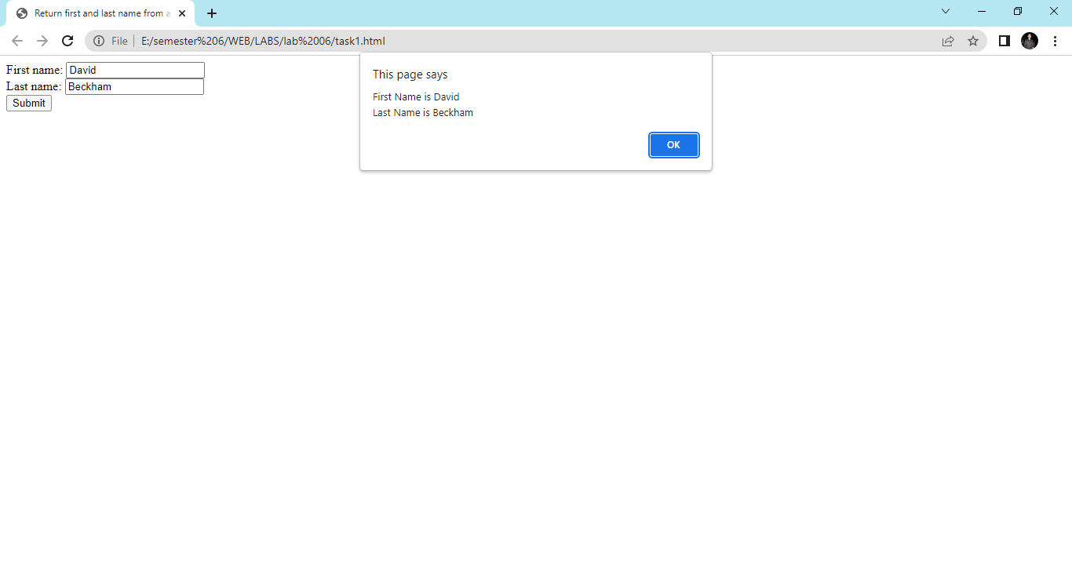

**Task 2**

**<!DOCTYPE html>**

**<html>**

**<head>**

**<meta charset=utf-8 />**

**<title>JS DOM</title>**

**<script language="javascript" type="text/javascript">**

**function set_background() {**

**bgc=document.querySelectorAll("p");**

**for(i=0;i<bgc.length;i++){**

**bgc[i].style.backgroundColor="red";**

**}**

**// document.getElementsByTagName("p")[0].style.backgroundColor="red";**

**// document.getElementsByTagName("p")[1].style.backgroundColor="yellow";**

**}**

**</script>**

**</head>**

**<body>**

**<input type="button" value="Click to set paragraph background color"onclick="set_background()">**

**<p id="p">w3resource JavaScript Exercises</p>**

**<p id="p1">w3resource PHP Exercises</p>**

**</body>**

**</html>**

**Output**

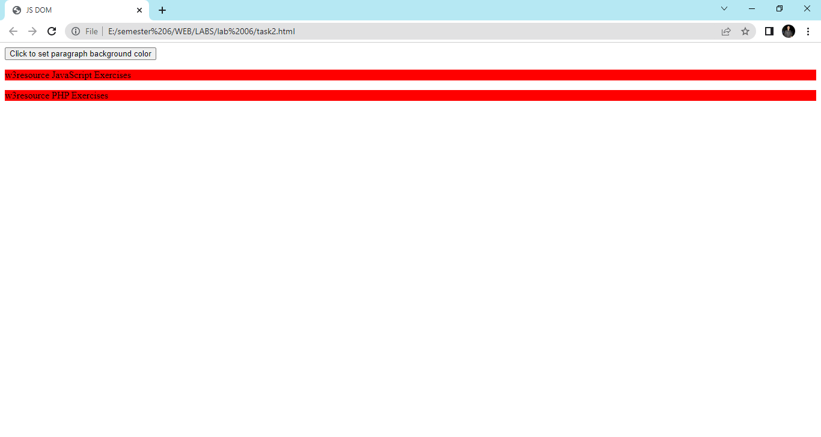

**TASK 3**

**<!DOCTYPE html>**

**<html>**

**<head>**

**<meta charset=utf-8 />**

**<script>**

**function getAttributes()**

**{**

**b = document.getElementById("w3r").href;**

**c = document.getElementById("w3r").hreflang;**

**d = document.getElementById("w3r").rel;**

**e = document.getElementById("w3r").target;**

**f = document.getElementById("w3r").type;**

**document.writeln('The value of the href attribute of the link is : '+b);**

**document.writeln('The value of the hreflang attribute of the link is : '+c);**

**document.writeln('The value of the rel attribute of the link is : '+d);**

**document.writeln('The value of the taget attribute of the link is : '+e);**

**document.writeln('The value of the type attribute of the link is : '+f);**

**}**

**</Script>**

**</head>**

**<body>**

**<p><a id="w3r" type="text/html" hreflang="en-us" rel="nofollow" target="_self"**

**href="http://www.w3resource.com/">w3resource</a></p>**

**<button onclick="getAttributes()">Click here to get attributes value</button>**

**</body>**

**</html>**

**Output**

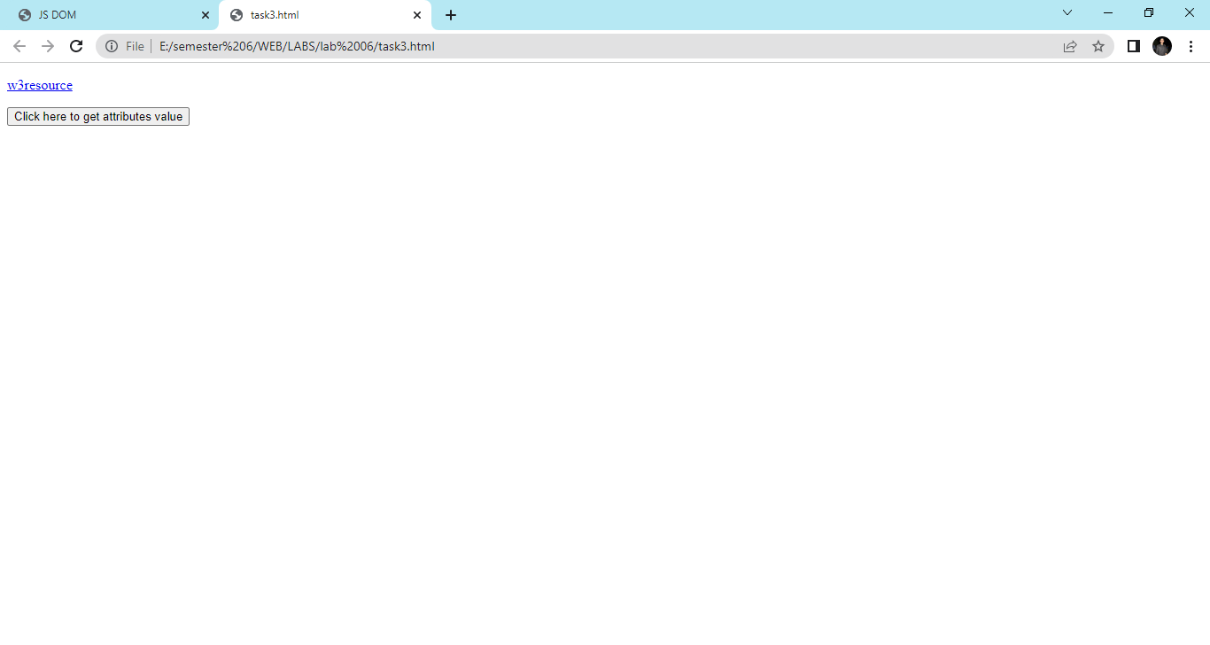

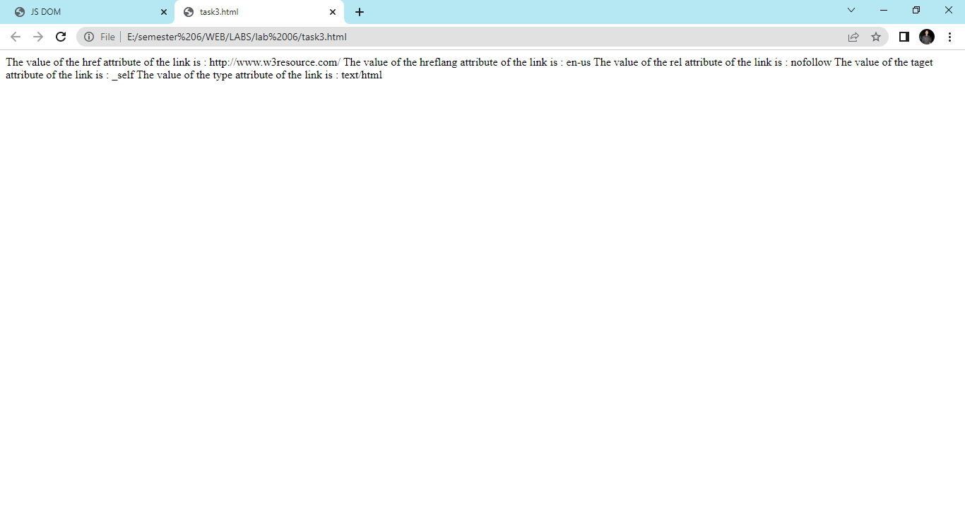

**Task 4**

**<!DOCTYPE html>**

**<html><br>**

**<head>**

**<meta charset=utf-8 />**

**<title>JS DOM paragraph style</title>**

**<script>**

**function js_style()**

**{**

**text.style.fontSize = "15px";**

**text.style.fontFamily = "serif";**

**text.style.color = "red";**

**}**

**</script>**

**</head>**

**<body>**

**<p id='text'>JavaScript Exercises - w3resource</p>**

**<div>**

**<button id="jsstyle" onclick="js_style()">Style</button>**

**</div>**

**</body>**

**</html>**

**Output**

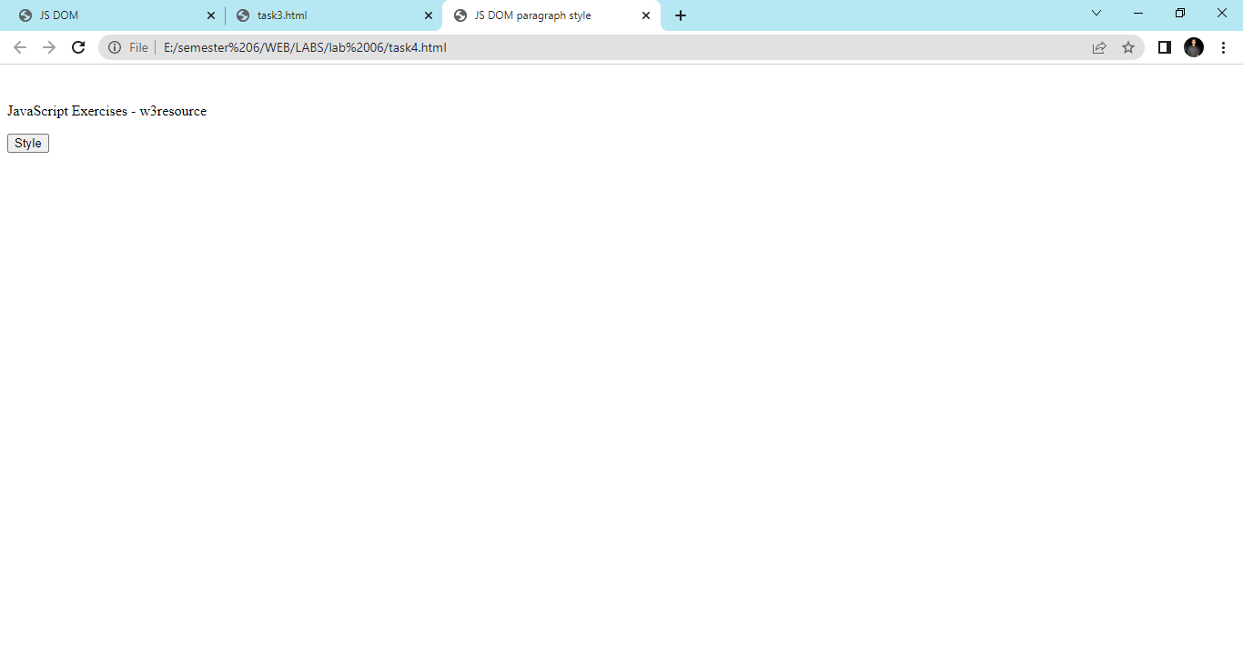

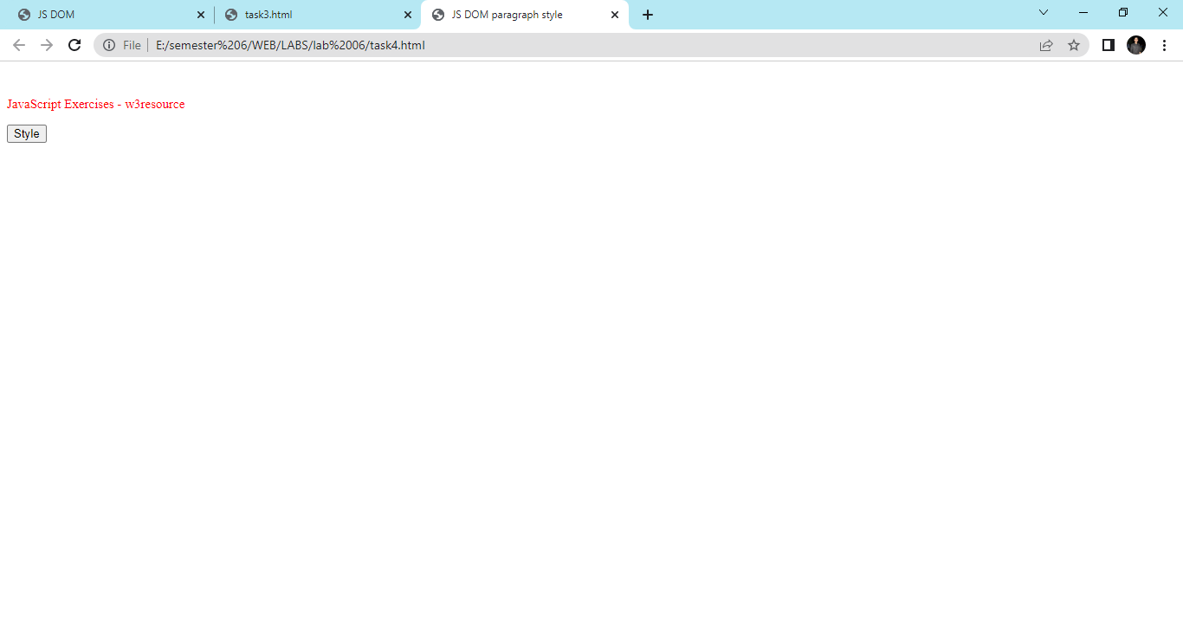

**Task 5**

**<!DOCTYPE html>**

**<html>**

**<head><br>**

**<meta charset=utf-8 />**

**<title>Insert row in a table - w3resource</title>**

**<script>**

**function insert_Row()**

**{**

**count=3;**

**x=document.getElementById('sampleTable').insertRow(0);**

**y = x.insertCell(0);**

**z = x.insertCell(1);**

**y.innerHTML="Inserted Cell"+count;**

**z.innerHTML="Inserted Cell"+count;**

**count+=1;**

**}**

**</script>**

**</head>**

**<body>**

**<table id="sampleTable">**

**<tr>**

**<td>Row1 cell1</td>**

**<td>Row1 cell2</td>**

**</tr>**

**<tr>**

**<td>Row2 cell1</td>**

**<td>Row2 cell2</td>**

**</tr>**

**</table><br>**

**<input type="button" onclick="insert_Row()" value="Insert row">**

**</body>**

**</html>**

**Output**

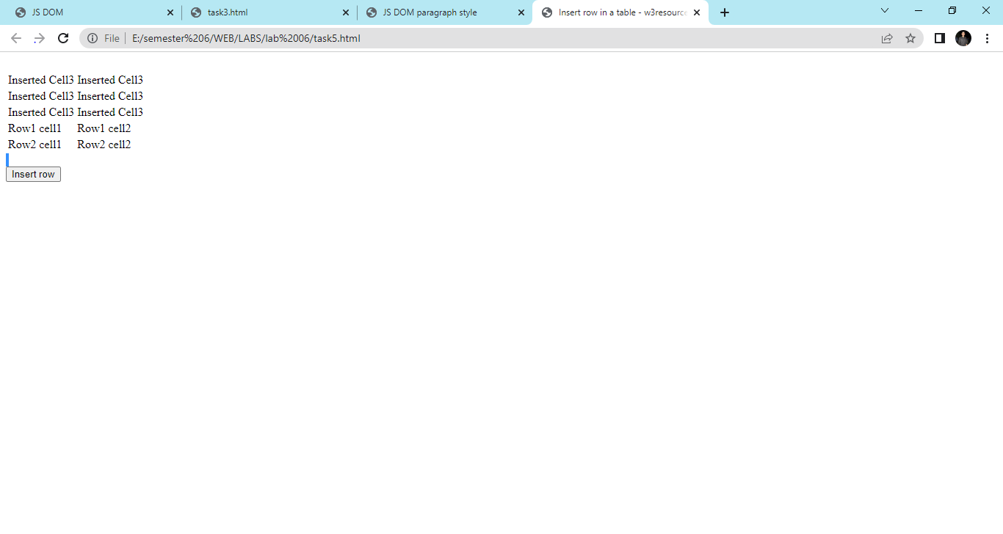

**Task 6**

**<!DOCTYPE html>**

**<html lang="en">**

**<head>**

**<meta charset="UTF-8">**

**<title>Document</title>**

**<script>**

**document.getElementsById("container");**

**document.querySelector("#container");**

**document.getElementsByClassName("second")**

**document.querySelector("ol .third");**

**b = document.querySelector("#container");**

**b.innerText = "Hello";**

**footer = document.querySelector(".footer");**

**footer.classList.add("main");**

**footerRrmove = document.querySelector(".footer");**

**footerRrmove.classList.remove("main");**

**newList = document.createElement("li");**

**newList.innerText = "four";**

**list = document.querySelector("ul");**

**list.appendChild(newLi);**

**var liInsideOl = document.querySelectorAll("ol li");**

**for(var i = 0; i < liInsideOl.length; i++){**

**liInsideOl[i].style.backgroundColor = "green";**

**}**

**var footer = document.querySelector(".footer");**

**footer.remove();**

**</script>**

**</head>**

**<body>**

**<div class="header">**

**</div>**

**<section id="container">**

**<ul>**

**<li class="first">one</li>**

**<li class="second">two</li>**

**<li class="third">three</li>**

**</ul>**

**<ol>**

**<li class="first">one</li>**

**<li class="second">two</li>**

**<li class="third">three</li>**

**</ol>**

**</section>**

**<div class="footer">**

**</div>**

**</body>**

**Output**

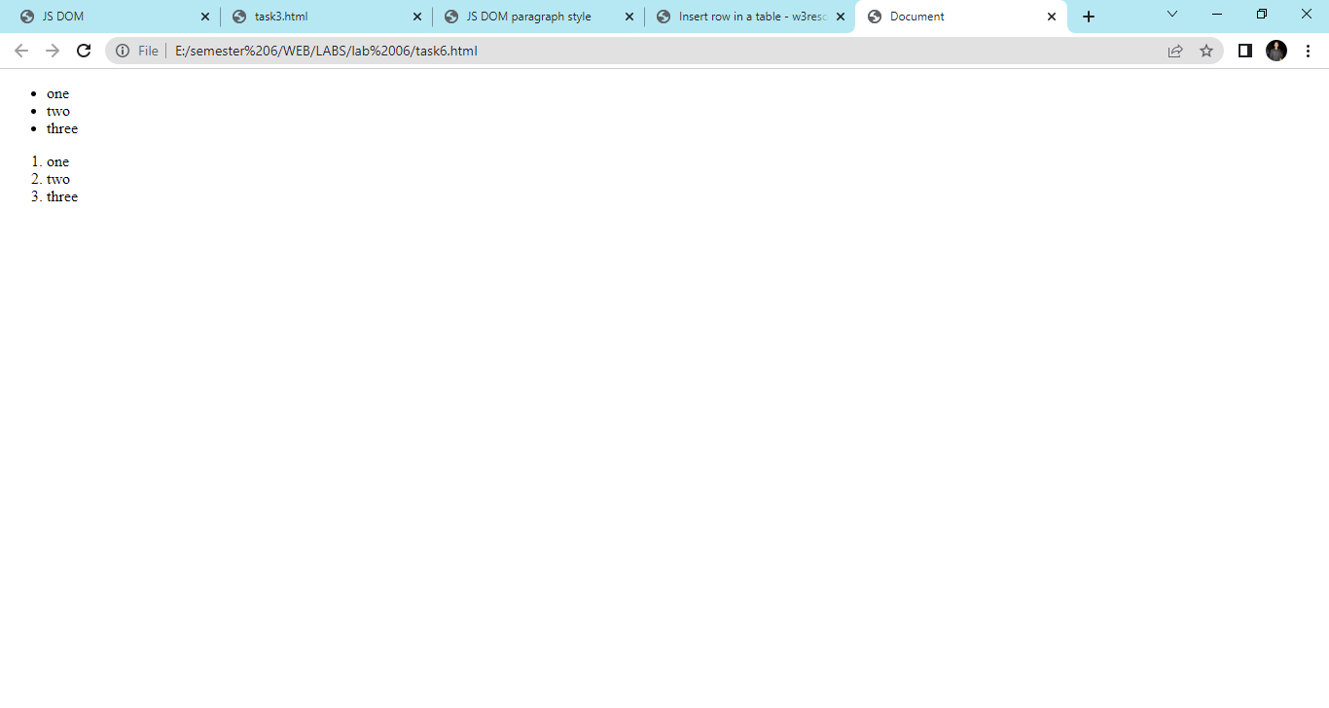

**Task 7**

**<!DOCTYPE html>**

**<html lang="en">**

**<head>**

**<meta charset="UTF-8">**

**<title>DOM Exercise</title>**

**<style>**

**div {**

**width: 50px;**

**height: 50px;**

**display: inline-block;**

**}**

**.brown{**

**background-color: brown;**

**}**

**.green{**

**background-color: green;**

**}**

**.blue{**

**background-color: blue;**

**}**

**.purple{**

**background-color: purple;**

**}**

**.yellow{**

**background-color: yellow;**

**}**

**.car1 {**

**background-color: #8C9C12;**

**}**

**.car2 {**

**background-color: #1DA788;**

**}**

**.car1, .car2 {**

**margin-left: 0;**

**}**

**</style>**

**</head>**

**<body>**

**<h1 id="change_heading">Change Me!</h1>**

**SELECTED COLOR <span class="selected">None!</span>**

**<section>**

**<div class="brown"></div>**

**<div class="green"></div>**

**<div class="blue"></div>**

**<div class="yellow"></div>**

**</section>**

**<h2>Race!</h2>**

**<button>Start the race!</button>**

**<br>**

**<div class="car1"></div>**

**<br>**

**<div class="car2"></div>**

**<script src="script.js"></script>**

**</body>**

**</html>**

**Output**

